1. Download gekodriver for your operating system from <https://github.com/mozilla/geckodriver/releases?ysclid=l5dp2lo2lb466065628>.
2. Move the loaded file into “discord-bot” folder.
3. Download PyCharm Community from <https://www.jetbrains.com/ru-ru/pycharm/download/#section=mac>.
4. Complete the installation by following easy steps.
5. Create a new project in PyCharm, choose name and directory for it.
6. Delete “main.py” by clicking on it and press delete button.
7. Drag all the files from “discord-bot” folder to the new made project, check picture below to make sure that you dragged it properly.

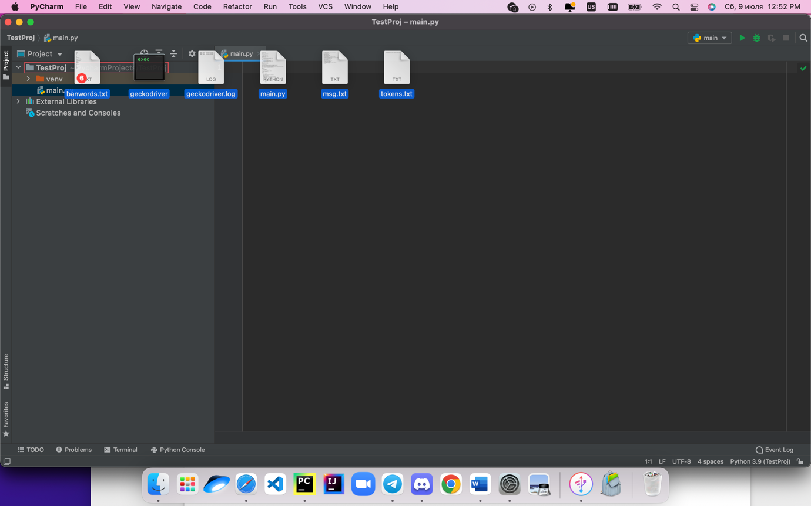



1. Open “tokens.txt”, write there your id token and chat id like this:   
   “yourTokenId:chatId”  
      
   <https://www.youtube.com/watch?v=qdKiU0JEbcY> – how to get your chat id   
   To turn on option for getting chat id:  
    open discord -> settings - > advanced -> turn on “developer mode”

Your id token will be always the same, but chat id might change. Chat token makes our bot understand in which chat it will send messages.

After you’ve turned it on, right click on the chat in which you need to send messages -> copy id

You can put several pairs of Id, this will allow your bot to send messages into different chats

1. Run project (click green triangle in the upper left corner).
2. Wait till all the files will be downloaded and the answer questions about sending delay and so on.
3. You can put and messages in “msg.txt”, bot will send them. “banwords.txt” – for those words which are not allowed to be sent in the channel.